**Rohail Ahmed**

**SP21-BCS-077**

**SECTION-BCS-6B**

**SUBMITTED TO SIR RASHID**

**Assignment 1**

Topics in Computer Science



Please make following routes and submit with code and screenshots

Employees Route

* The contents of routes/employees.js will be:
* 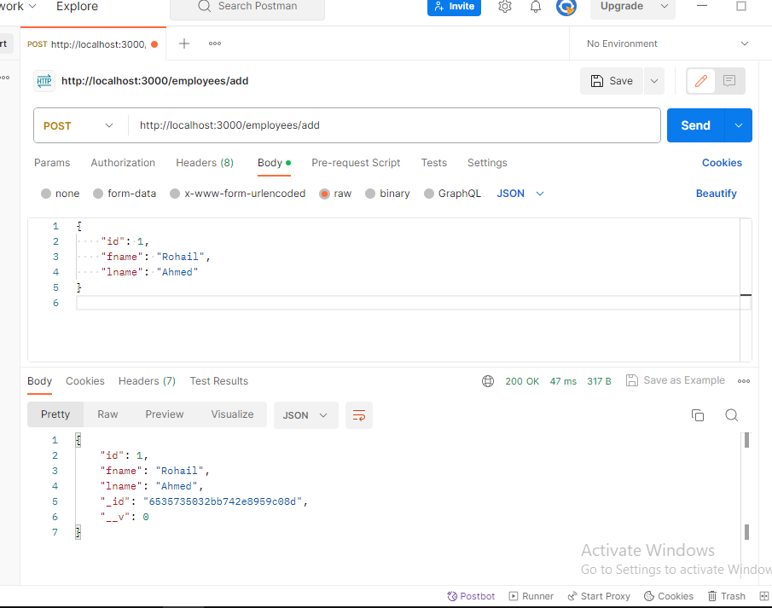
* GET /employees ― returns all employees, sorted by last name

module.exports.view = function (req, res) {

    employee.find().sort({ fname: 1 }).then((result) => {

        res.json(result);

    }).catch((err) => {

        res.json(err);

    });

}

* 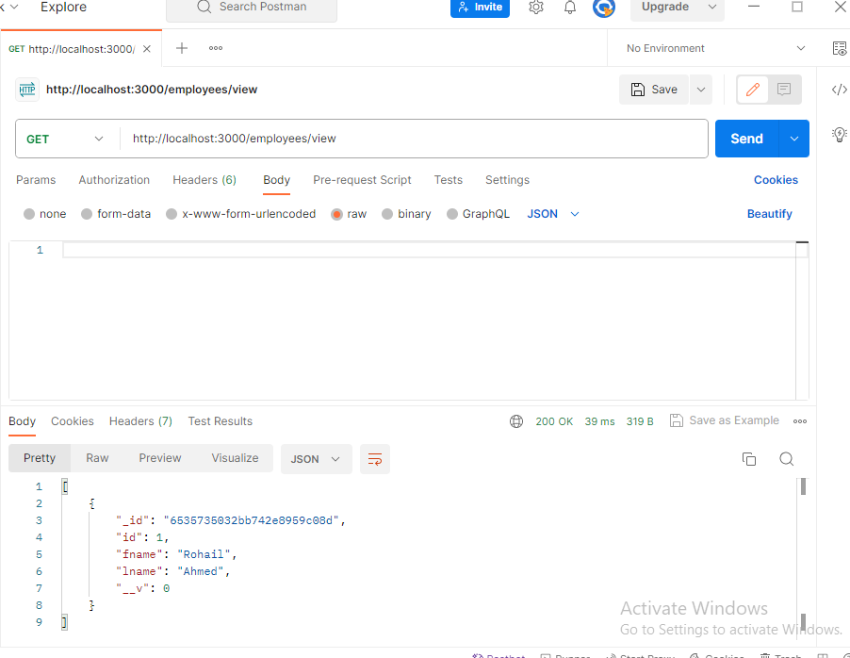
* GET /employees/:employeeId ― returns information for a single employee, whose employee ID is passed through the employeeId parameter

module.exports.viewbyid = function (req, res) {

    employee.find({ id: req.params.id }).exec().then((result) => {

        res.json(result);

    }).catch((err) => {

        res.json(err);

    });

}

* 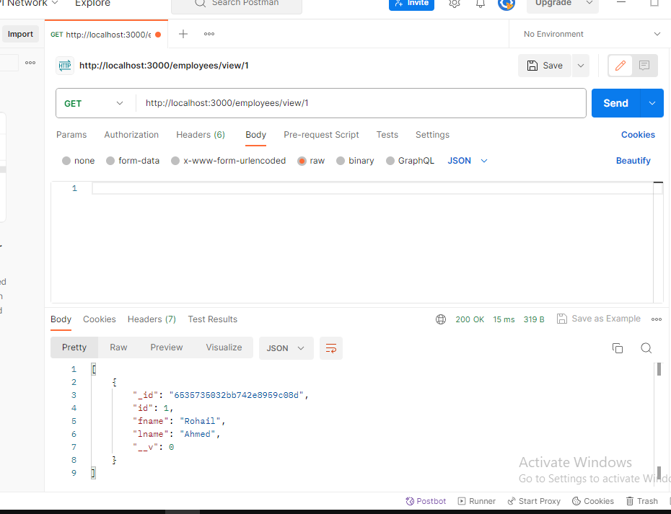
* PUT /employees/:employeeId ― used to update an existing employee; the employee. ID is passed through the employeeId parameter, while the employee data is passed in the request body.

module.exports.update = function (req, res) {

    employee.findOneAndUpdate({ id: req.params.id }, { fname: req.body.fname, lname: req.body.lname }.then((result) => {

        res.json(result);

    }).catch((err) => {

        res.json(err);

    }));

}

* 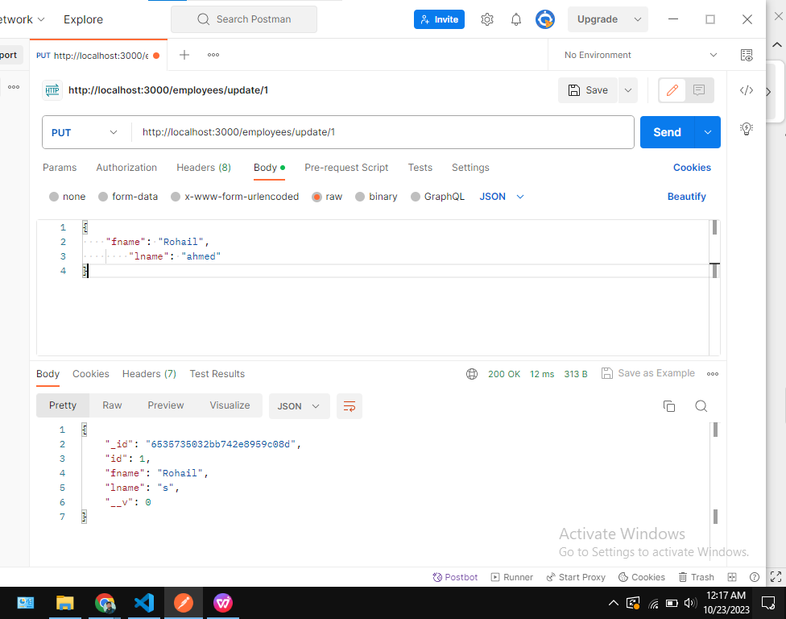

Teams Route

* The following teams routes will be implemented:
* GET /teams ― displays all the teams stored in the database, sorted by team name

module.exports.view = function (req, res) {

    team.find().sort({teamname: 1}).then((result) => {

        res.json(result);

    }).catch((err) => {

        res.json(err);

    });

}

* 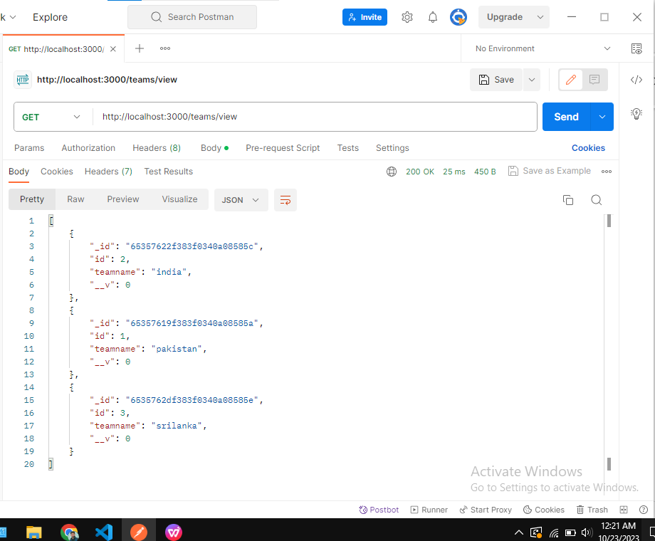
* Delete /teams/:teamId—displays information regarding a single team; the team’s ID is passed through the teamId parameter.

module.exports.delete = function (req, res) {

    team.deleteOne({ id: req.params.id }).then((result) => {

        res.json(result);

    }).catch((err) => {

        res.json(err);

    });

}

